Faculty of Computing

Year 2 Semester 1 (2025)

IT2120 - Probability and Statistics

Lab Sheet 05

It24104345

Madhushika W.A.M

**Exercise**

1)

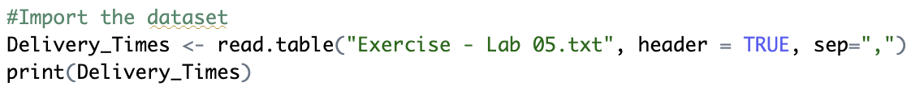

2)

3. Comment on the shape of the distribution.

The distribution of delivery times is right-skewed, with the majority of delivery times falling between 30 and 45 minutes. A few higher values (above 50 minutes) extend the tail to the right.

4. Draw a cumulative frequency polygon (ogive) for the data in a separate plot

